Terraform challenges – 02
Goal of the Exercise
The goal of this exercise is to test your understanding of a Cloud Compute deployment with Terraform.
You are tasked with creating a codebase for a microservice deployment on a cloud environment, using Terraform. Since our focus is not the application itself, the service will be a simple web server that returns a static page.
Requirements
Service Details
- The service will be a simple web server that returns a static page.
- You can useapache2ornginxto serve a simple HTML file.
- The service should becontainerizedand stored in aDocker registry.
- The service should be deployed on asingle VM instanceas a docker container.
- The image should be pulled from the registry specified earlier.
- The service shouldnotbe accessible from the internet but only through aLoad Balancer, except for SSH access from specific IP addresses.
Deliverables
You are to provide the following as part of your solution:
- Dockerfileto build the image.
- Terraform codebaseto deploy the following:
  - Docker registry
  - VPC and all required networking resources
  - EC2 instance
  - Load Balancer
Notes
- Since a CI/CD pipeline is not part of this exercise, we will work around that with the help of Terraform.
- To push the image to the Docker registry,build the image locallybefore running the Terraform code.
- Once the image registry is created, use Terraform topush the local imageto the registry.
- Similarly, use Terraform topull the imagefrom the registry and run it on the VM instance once it is created.
- For SSH access:
  - Use a locally created key.
  - Add it to the cloud provider key storage.
  - Attach it to the instance.
- UseTerraform best practicesfor file structure and code organization.
  - Use variables, locals, modules, etc. when appropriate.
- Include alltfvars, scripts, and other helper files used to deploy the application.
- You may use any cloud provider of your choosing, althoughAWS is preferred.
- Use afree tier accountor atrial accountto deploy the resources
--> First we created that files
Terraform
Dockerfile
index.html
Main.tf
Output.tf
Variables.tf
Terraform.tfvars
Providers.tf

First I created Dockerfile-->index.html
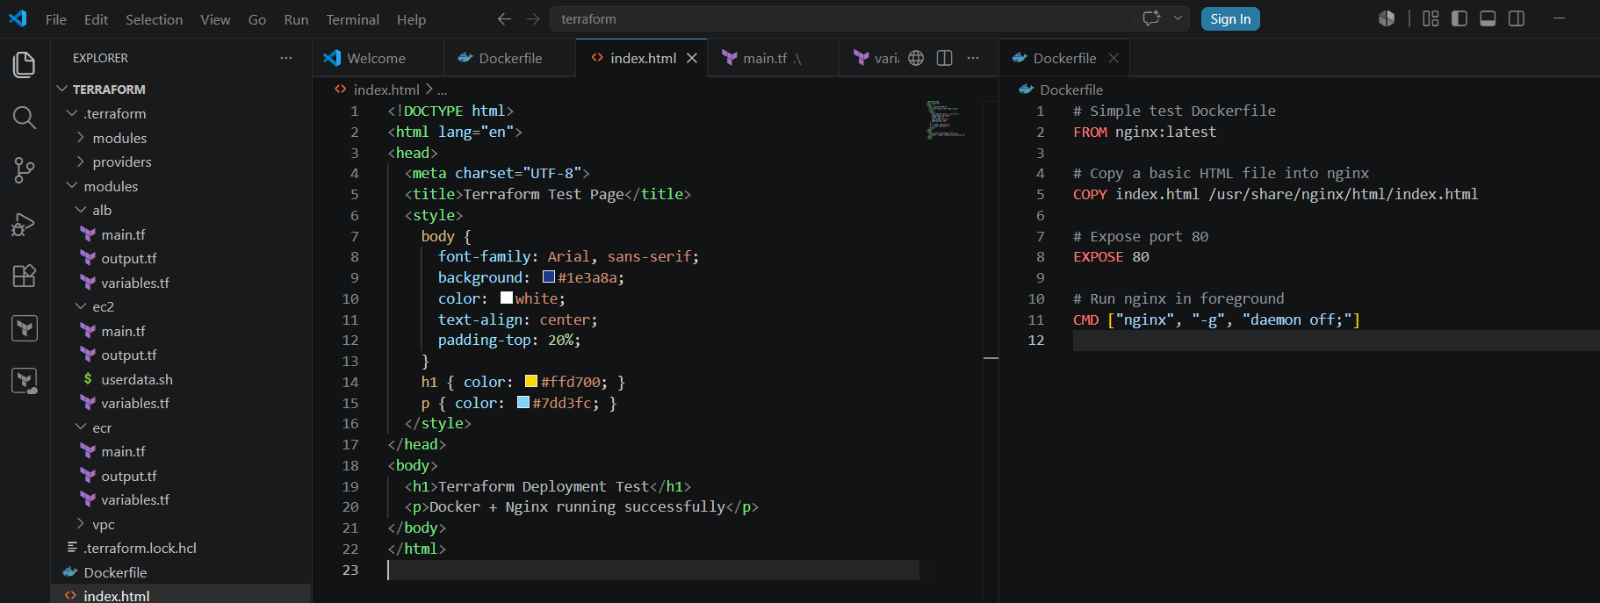
Create Main.tf
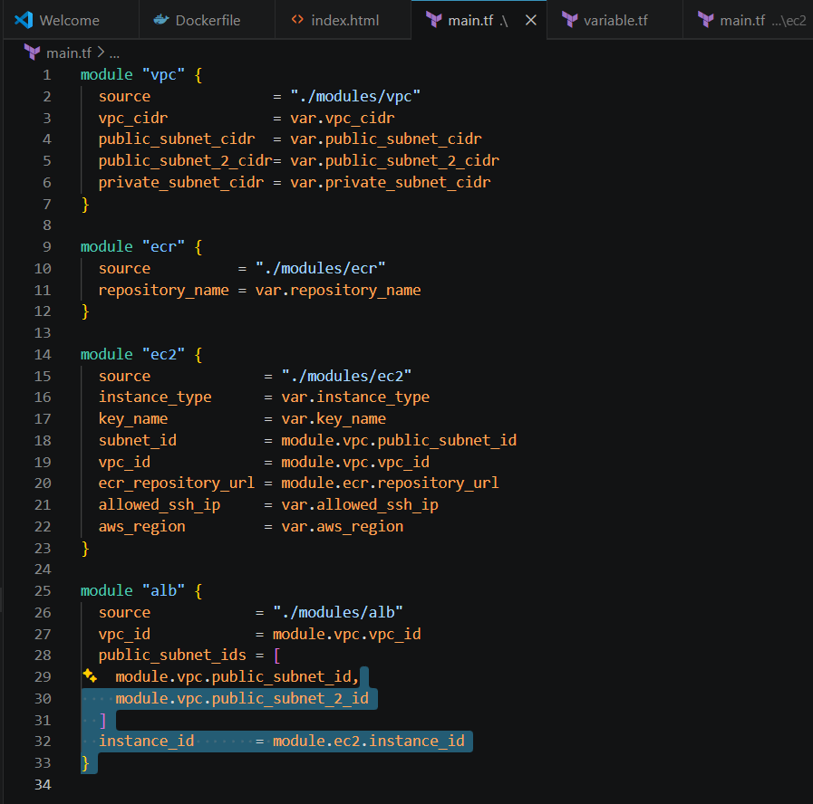
Create Output.tf
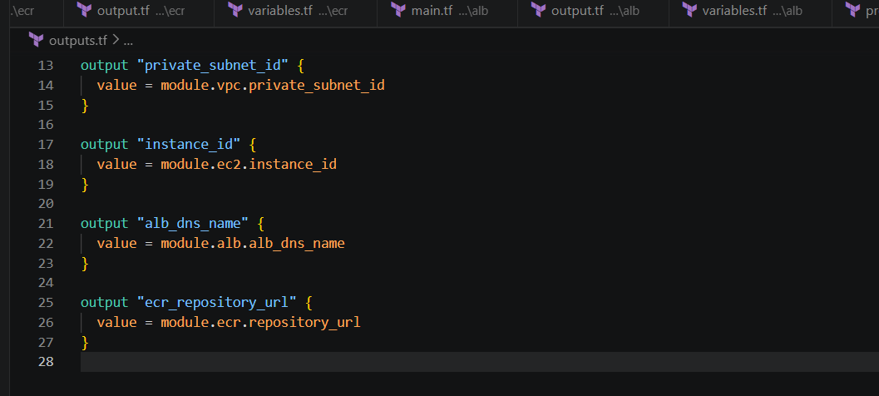
Create Providers.tf
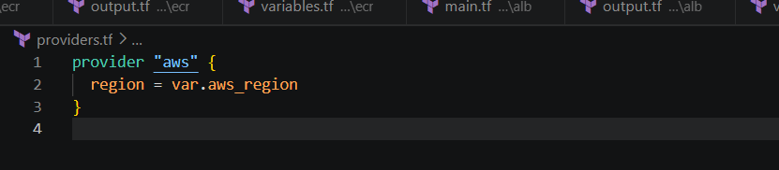
Create terraform.tfvars
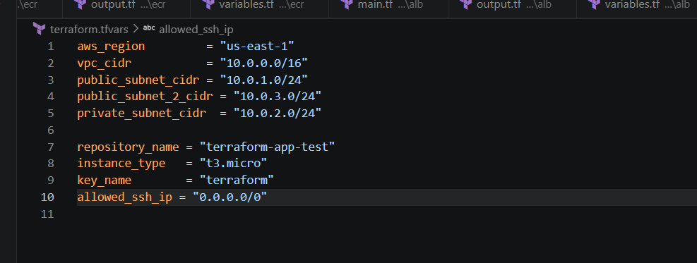
Create Variables.tf
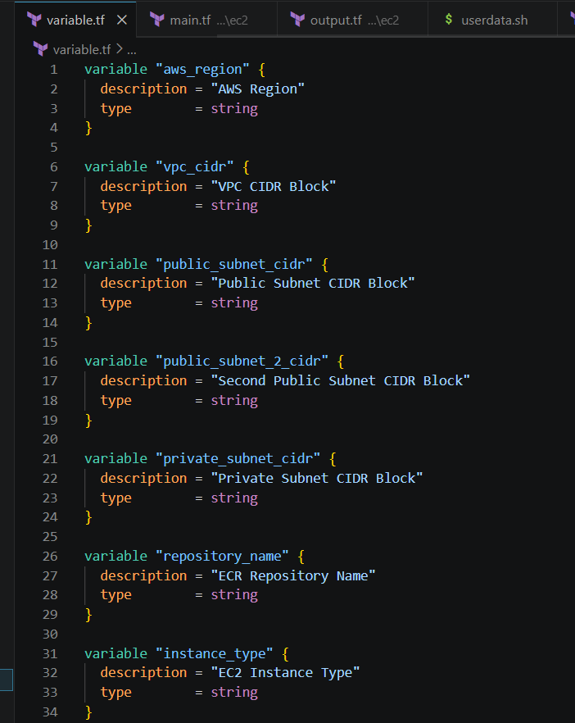
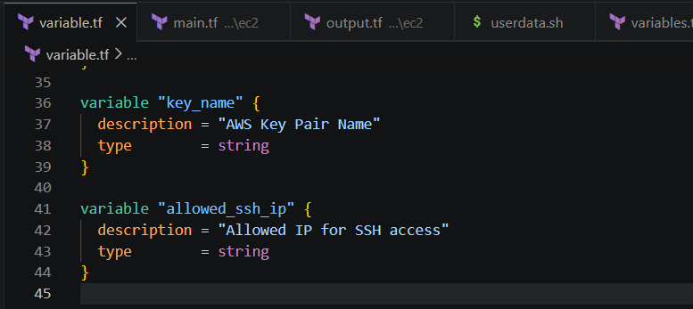
Next I have created a folder called modules and inside the folder I have
created a ec2 folder
Main.tf
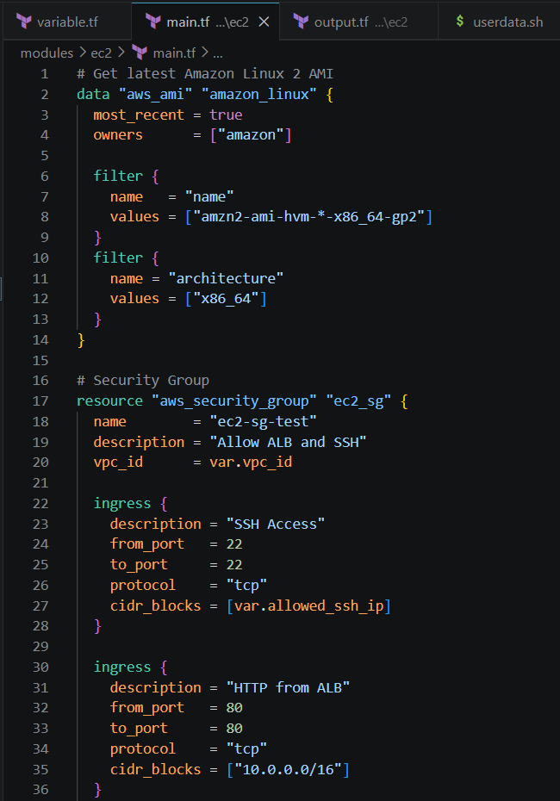
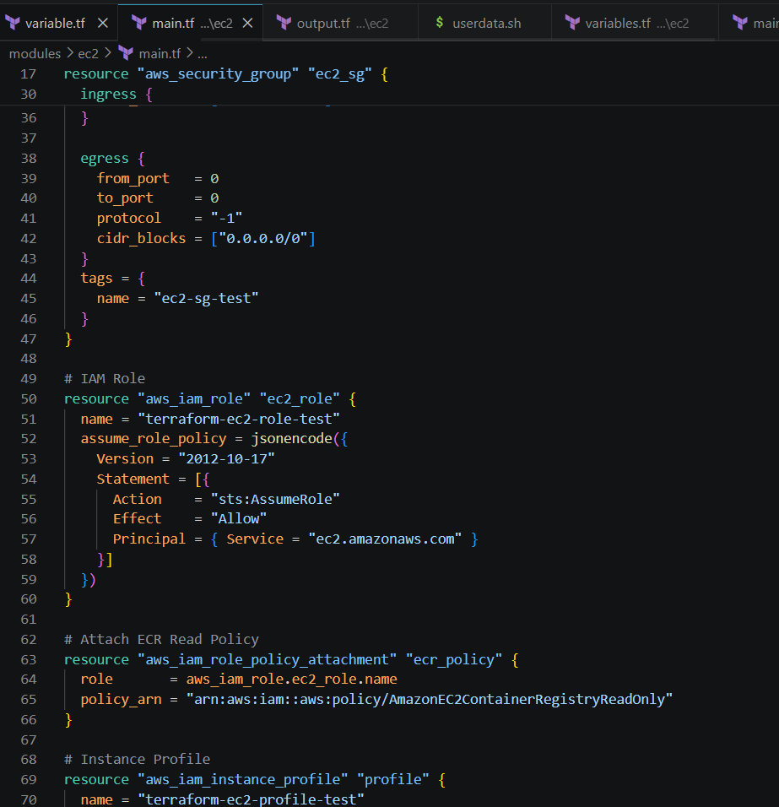
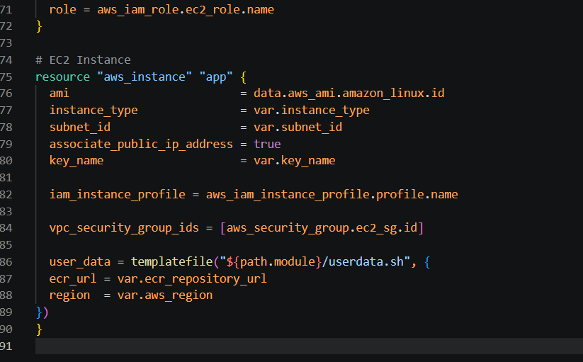
Output.tf
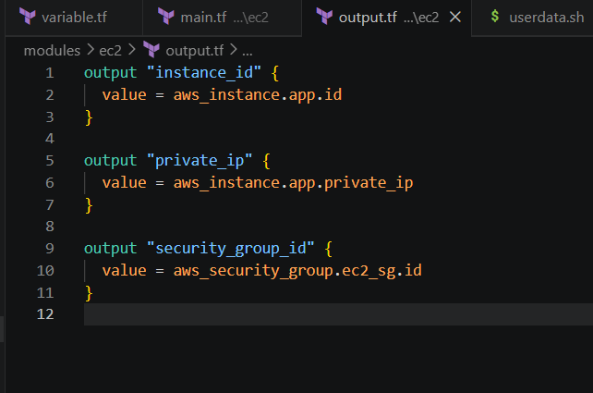
Variables.tf
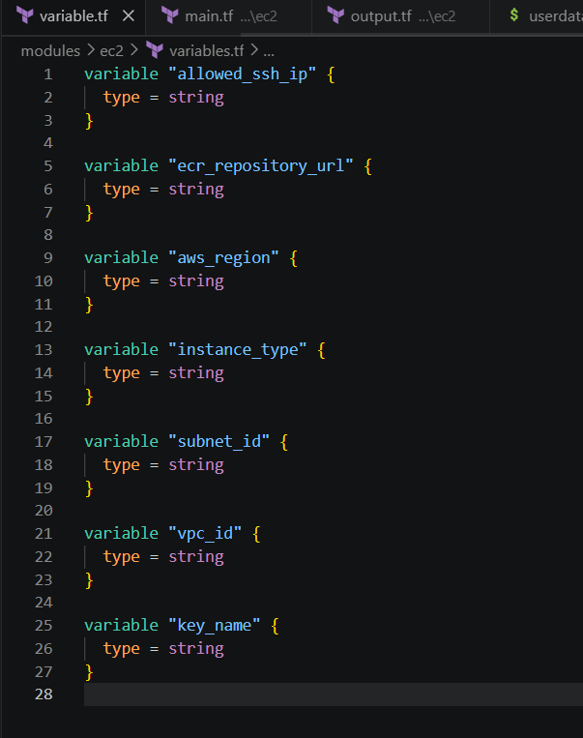
Userdata.tf
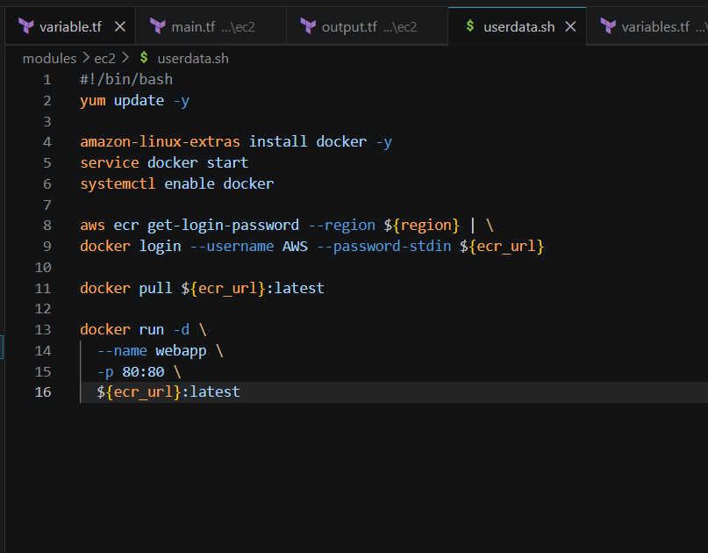
Now lets inside the modul I have create vpc folder
Main.tf
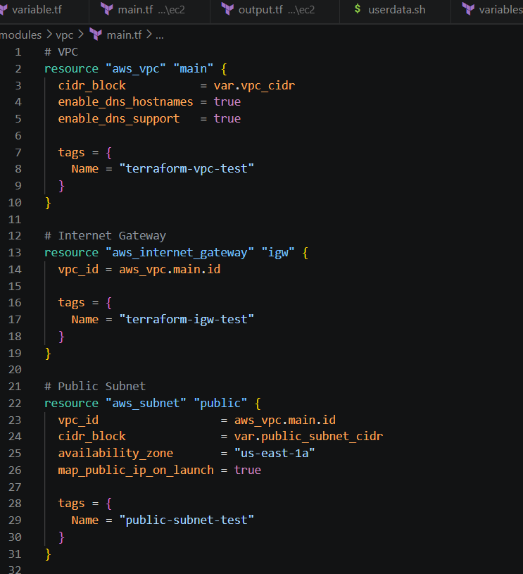
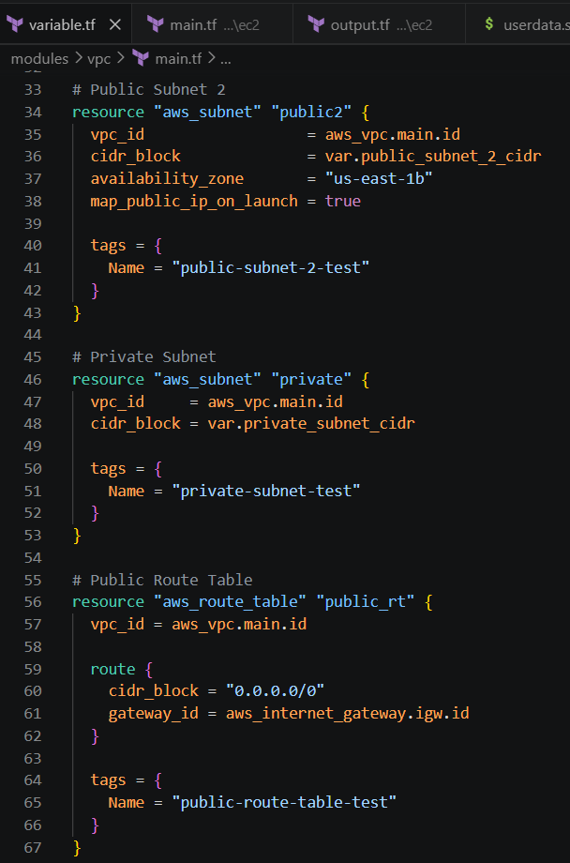
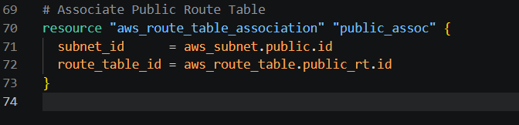
Output.tf
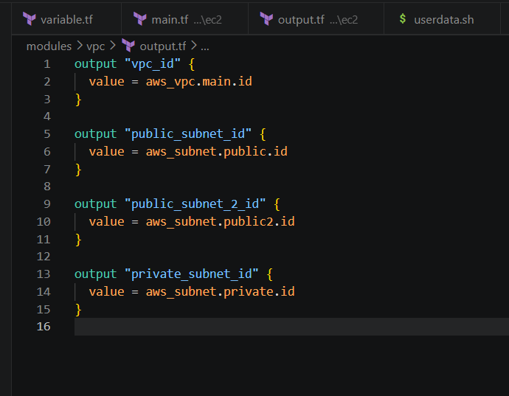
Variables.tf
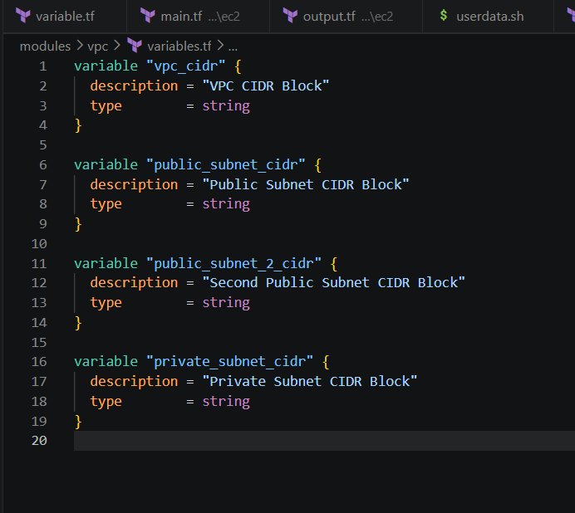
Inside the modul I have created the ecr folder
ECR
Main.tf
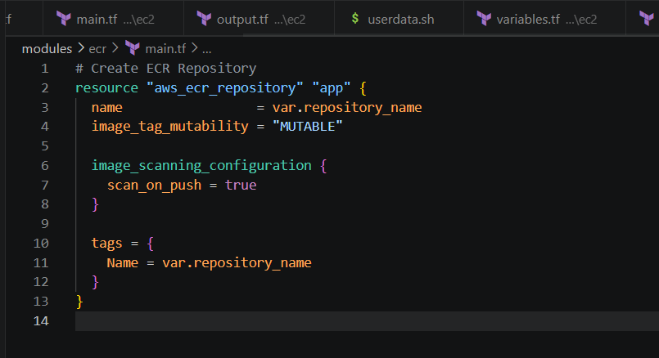
Output.tf
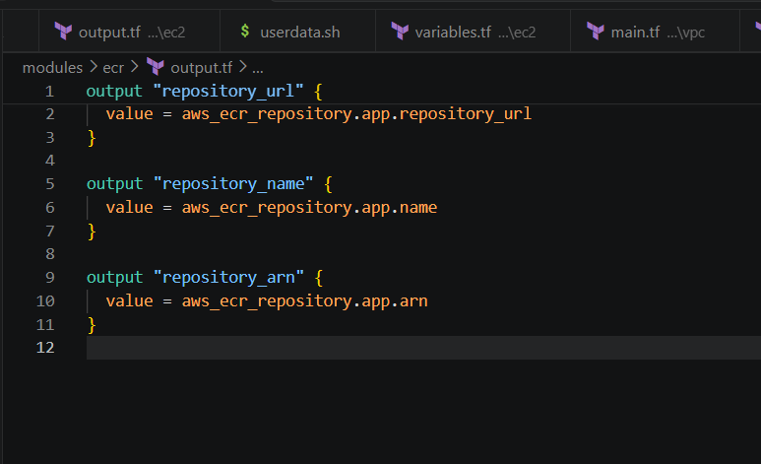
Variables.tf
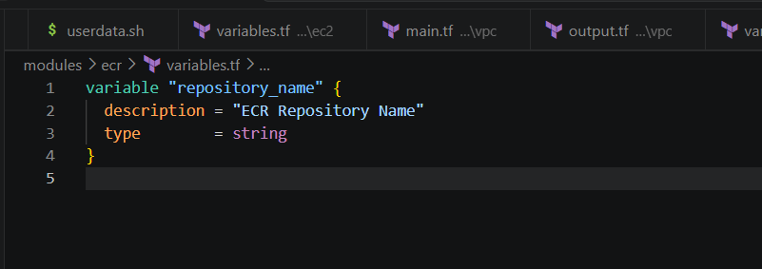 Inside modules I have created another folder called ALB
ALB
Main.tf
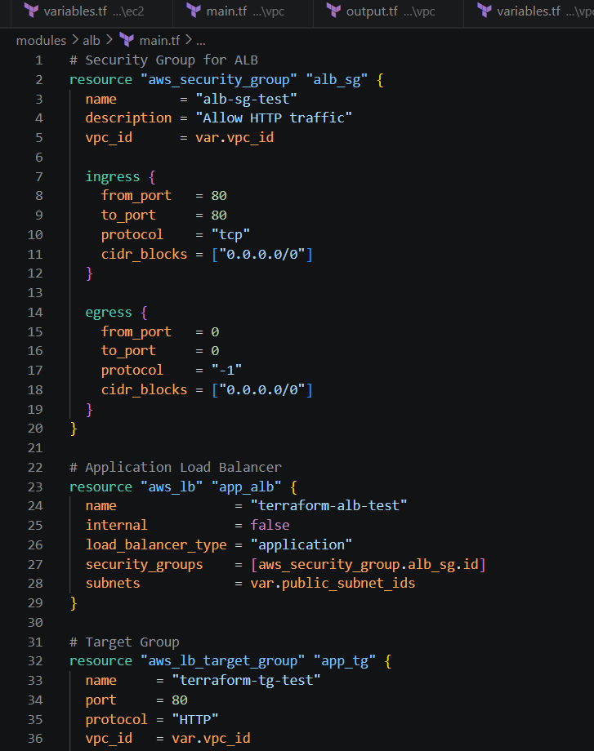
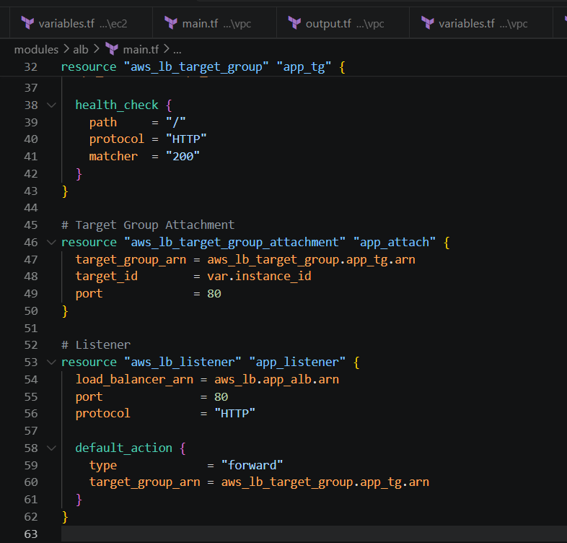
Output.tf
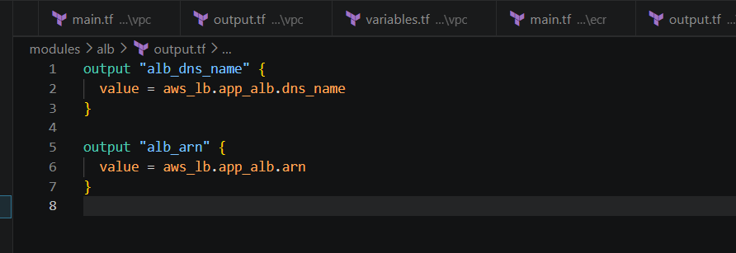
Variables.tf
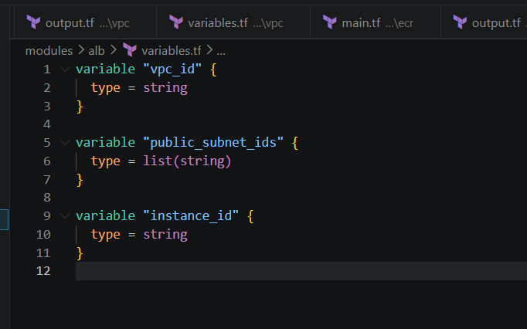
Lets all files
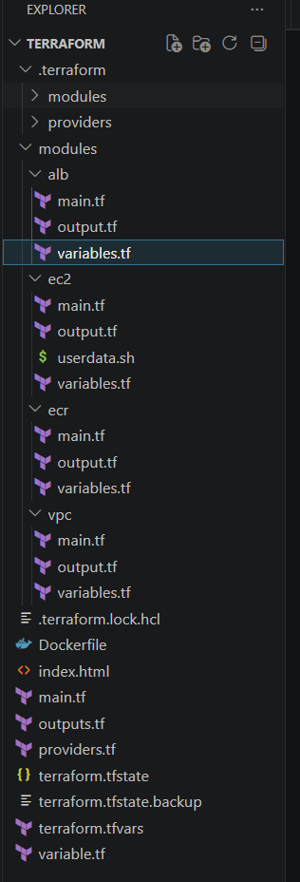
Now lets I performd the
--> terraform init
--> terraform plan
--> terraform apply
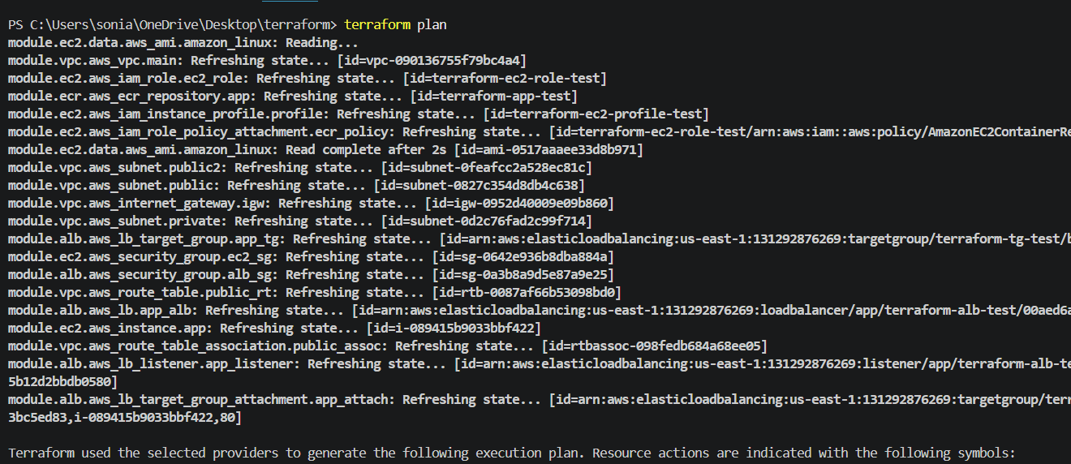
Terraform apply
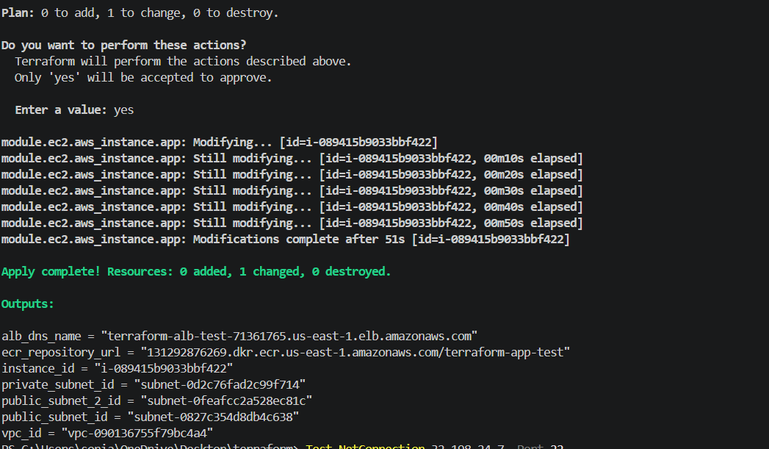
Download docker on desktop
-->docker build -t terraform-app .
-->aws ecr get-login-password --region us-east-1 | docker login --username AWS --password-stdin 131292876269.dkr.ecr.us-east-1.amazonaws.com
-->docker pull 131292876269.dkr.ecr.us-east-1.amazonaws.com/terraform-app-test:latest
-->docker run -d -p 80:80 --name webapp 131292876269.dkr.ecr.us-east-1.amazonaws.com/terraform-app-test:latest
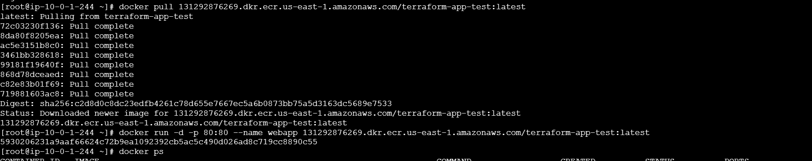
Then verified in the AWS
ECR is created and pusheed the images
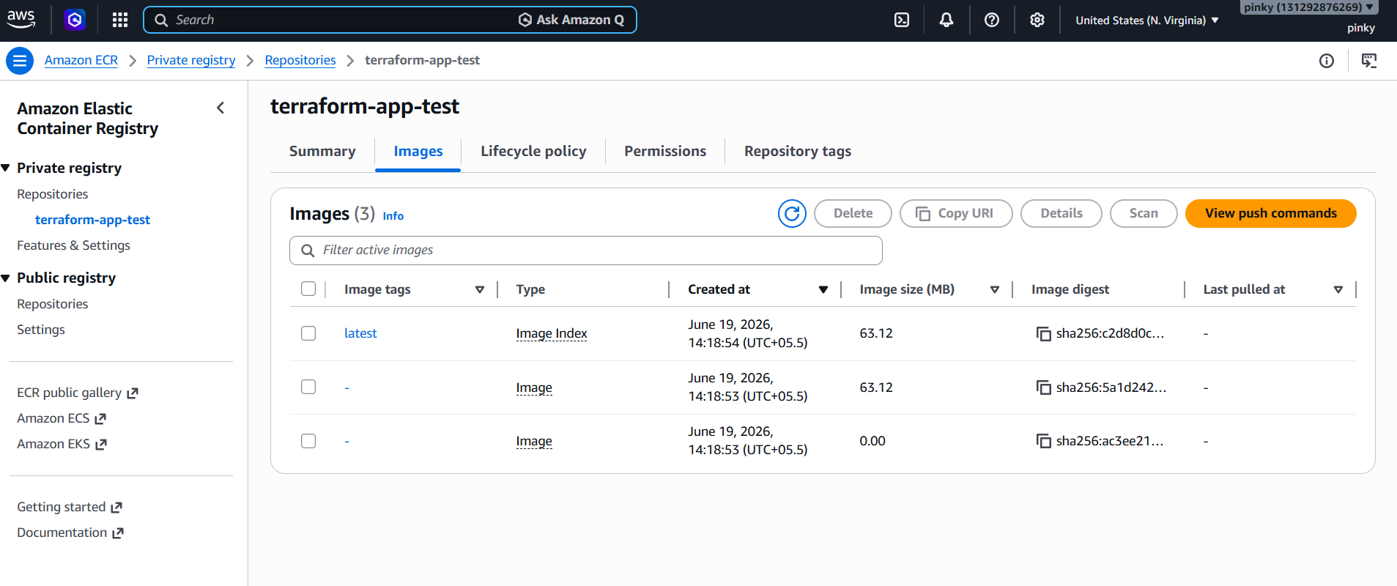
Ec2 is created
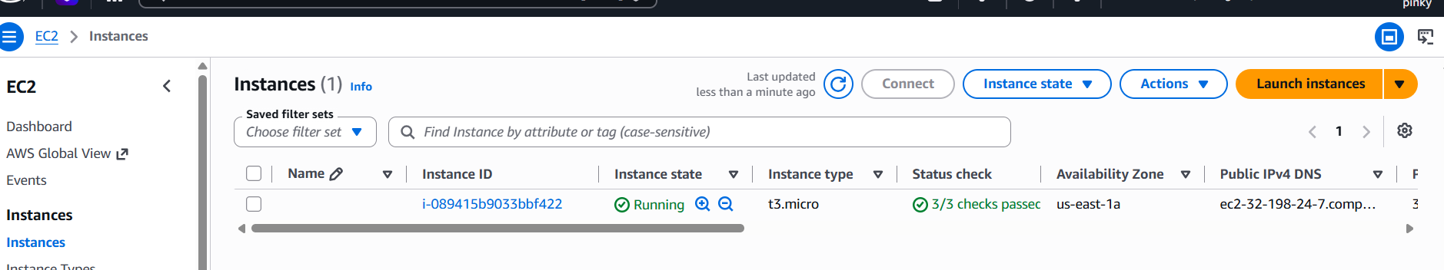
Load balancer is also created
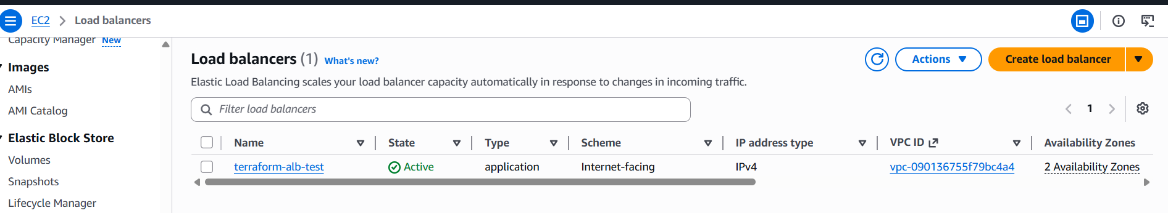
Target groups are created
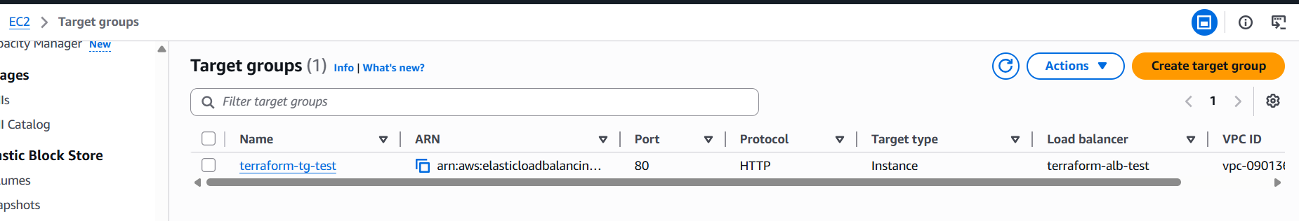
Vpc created
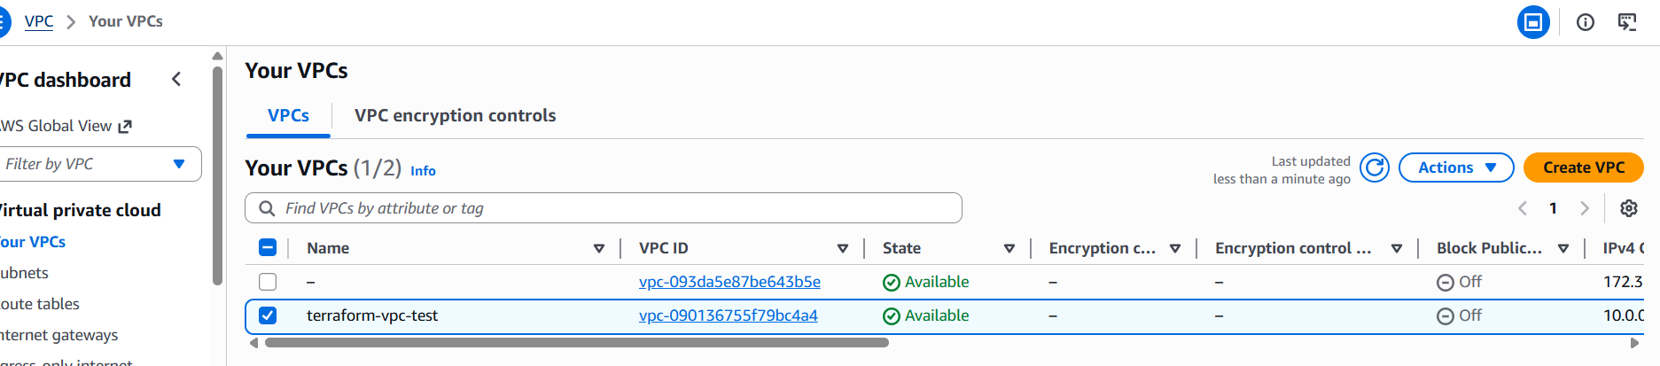
Subnets ara created in different availabilty zones
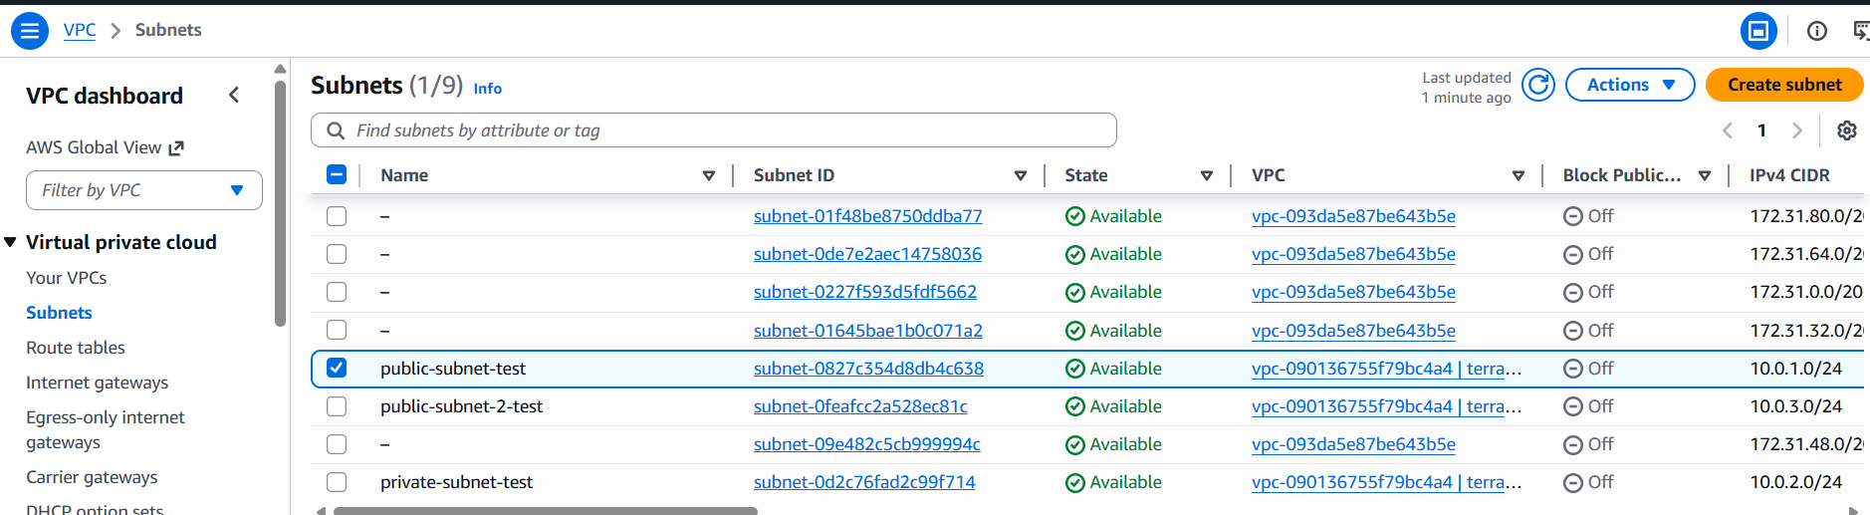
Created the route table
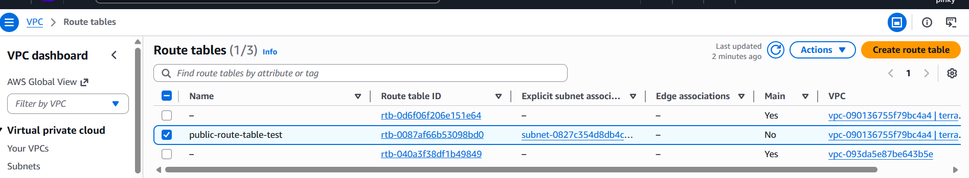
Created internet getway
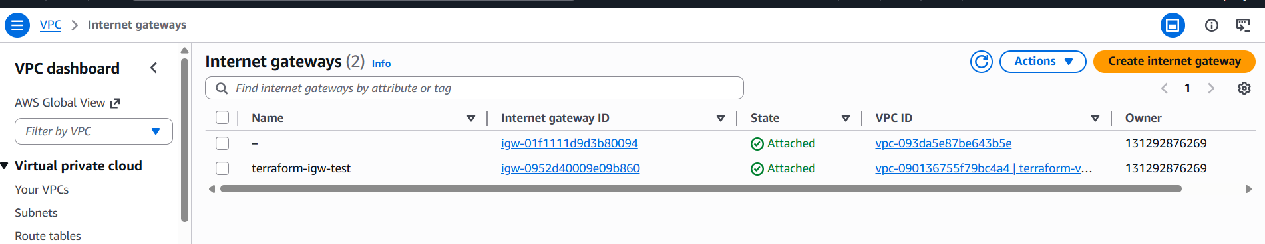
Subnet association
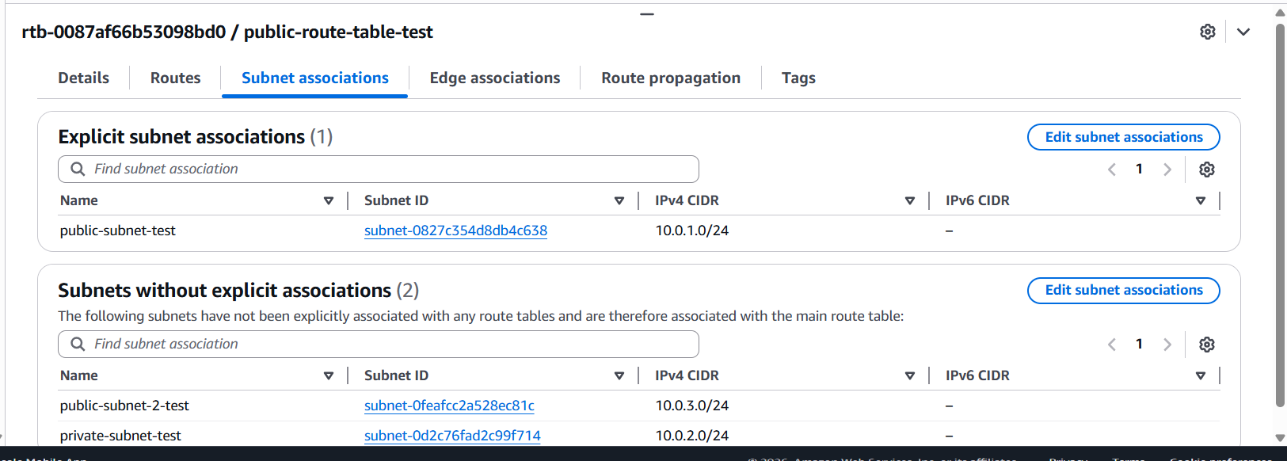
Security groups
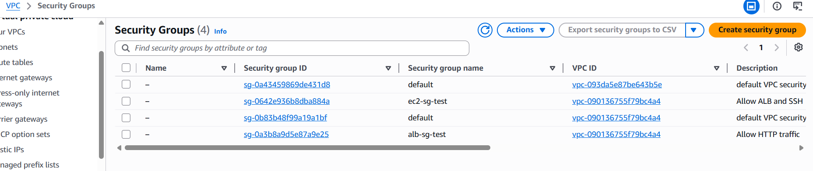
Iam role
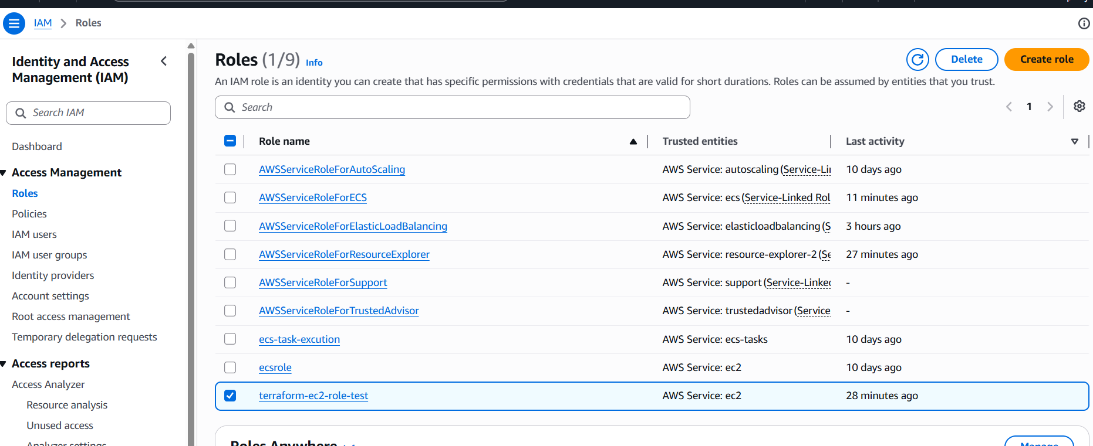
Index.html file is execute successfully with ALB DNS
